Outline:
- Defining Cessationism
- The Importance of CHARISmata
- Development of Cessationism
- Continuation of Charismata Through History
- Main Cessationist Arguments
- Biblical Case For Continuation
- Biblical Case For Cessationism
- The Turning Tide
- Why it Matters

Defining Cessationism:
Cessationism - the belief that all “sign” “miraculous” “revelatory” or “supernatural” gifts ceased after the Apostles, and they are not of use in today’s church
Continuationism - The belief that these gifts never ceased, and that they are not only available, but meant to be a normative expression in the church today

***Special note*** For the purposes of this class, we are lumping in Pentecostals and Charismatics, sometimes coupled as “renewalists”. In other words, people that believe in Spirit-empowered ministry today. I use Charismatic most - GB

Cessationists make a distinction about the gifts that the Bible doesn't make - “Sign” gifts vs. the Others

Common Scriptural Gift Lists:
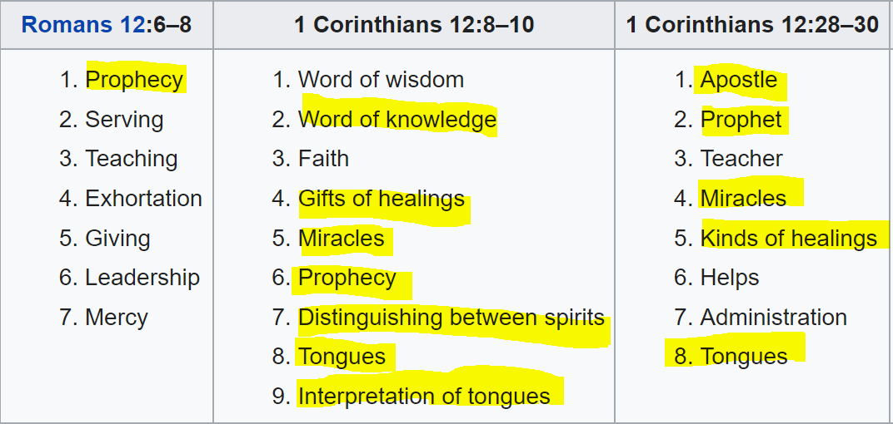
The highlighted gifts would be gone under cessationism

The devil's finest works are those things He suggests as theologies and doctrines. Especially those that rob believers of things that are rightfully theirs; Those things which cause believers not to believe what God is clearly told them or cause them to not obey what God is clearly called them to obey. His magnum opus is the cessation of the gifts. GB

Liberalism and cessationism - know them well. They are responsible for much of the unbelief in the church today

The Importance of CHARISmata

The root word in Charismata “Spiritual Gifts” is Charis, the NT word for Grace

We can not let the idea of operating in these gifts to ever lead to an elitist mentality.

They are gifts, not badges of honor

Romans 1:11
“For I long to see you so that I may impart some spiritual gift (charisma) to you, that you may be [fn]established;”
Charisma:
a favour with which one receives without any merit of his own
the gift of divine grace
the gift of faith, knowledge, holiness, virtue
the economy of divine grace, by which the pardon of sin and eternal salvation is appointed to sinners in consideration of the merits of Christ laid hold of by faith
grace or gifts denoting extraordinary powers, distinguishing certain Christians and enabling them to serve the church of Christ, the reception of which is due to the power of divine grace operating on their souls by the Holy Spirit

Development of Cessationism

The cessationist polemic, which was often directed against persons or groups claiming religious authority via any exhibition of divine healings, prophecies or miracles, recurs consistently from within such conflict settings throughout the history of the church and even within rabbinic Judaism. But it emerged in its modern form most prominently in the conflict between Rome and the Protestant reformers, notably Calvin, then again during the Enlightenment in ’[sic] the ‘great debate on miracles’, and presently in the twentieth-century opposition to the

Pentecostal-charismatic movement. In recent years the advancing front of charismatic growth has precipitated showers of polemical books and tracks, virtually all reiterating the cessationist premise. - Ruthven

First 500 years of church, Charismata can be seen as “normative”
For 1000 years from that, no Word for the people - Dark ages
- Heavy limitation on the laity, emphasis on clergy
- People with no Word and no opportunity did not do the “stuff”

Chrysostom, Augustine, Aquinas - formative early voices
Augustine and Aquinas (all straw) changed their tune

Then Protestant Time
Luther (out of context), Calvin
Super overcorrection to Catholic Church - protestants became synonymous with cessationists
All about doctrine

Enlightenment Period On
BB Warfield - Counterfeit miracles - still a standard for cess
Warfield claimed that not a single miracle has occurred since the last apostle died.
Common Sense and Rationality - religion for all, in a sense
Hume in all colleges

Modern - John F. MacArthur, Hank Hanegraaff, to name a few

Continuation of Charismata Through History

Contrary to popular belief, there is consistent testimony throughout most of church history concerning the operation of the miraculous gifts of the Spirit. - Sam Storms

I had the false belief that nothing happened for thousands of years. But that is absolutely not true. There is always been somebody that is kept the flame burning.

Washing of History - Randy Clark Shantung Revival Example

See “Continuation History Reference up until 1900s”

Main Cessationist Arguments

- The Value of Suffering - “To experience suffering for God is better than to experience miracles from Him”
- Adding to the Scripture - The idea that the canon is closed, so there’s no need for revelatory or miraculous gifts
- Apostle Problem/Foundation - Out of Ephesians 2:20, the idea that since the foundation is laid, no need for apostles and their signs or prophets and theirs.
  - (1) the 70 who were commissioned in Luke 10:9, 19-20;
(2) at least 108 people among the 120 who were gathered in the upper room on the day of Pentecost;
(3) Stephen (Acts 6-7);
(4) Philip (Acts 8);
(5) Ananias (Acts 9);
(6) church members in Antioch (Acts 13);
(7) anonymous converts in Ephesus (Acts 19:6);
(8) women at Caesarea (Acts 21:8-9);
(9) the unnamed brethren of Galatians 3:5;
(10) believers in Rome (Rom. 12:6-8);
(11) believers in Corinth (1 Cor. 12-14)
(12) Christians in Thessalonica (1 Thess. 5:19-20)
  - All people who were not apostles operating in gifts
- Now We Have Love - no “need of signs”, and the Perfect Scripture - the idea out of 1 Corinthians 13 that because we have “love” we’ve matured from the need for signs, and that the “Perfect” has come means the canonization of Scripture
- Subjective Experience - Miracles can’t be verified, so they can’t be trusted. Or I don’t see it, so it doesn’t happen.
- Weak Faith/Strong Faith - Now that the church has matured, no need for that weak stuff
- Deliverance from Sin is greater - We have deliverance from sin, which is greater, so that’s good enough

Problems: Waffling, subjective reasoning on their part, distinction in gifts, and the “moving target”

***Moving Target of the timing of the cessation - at least 12 diff propositions
after the writing of 1 Corinthians, the book of Hebrews, or the last New Testament book; at the closing of the canon of Scripture; when the New Testament was ‘accepted’ or ‘circulated’; at the death of the last apostle; the death of the last disciple on whom the apostles confirmed a
charism; when the apostolic age passed; at the destruction of Jerusalem; when the Church matured in ‘love’ or in ‘doctrine’; until faith was established; ‘ when the whole knowledge of God designed for the saving the health of the world had been incorporated into the living body of the world’s thought

Biblical Case for Continuation

- John 20:21 "As the Father has sent me, I am sending you."
- Matt 28: 19-20 "Therefore go and make disciples ... 20 and teaching them to obey everything I have commanded you."
- Mark 16: 17-18 " And these signs will accompany those who believe: in my name they will drive out demons; they will speak in new tongues; 18 they will pick up snakes with their hands; and when they drink deadly poison, it will not hurt them at all; they will place their hands on people who are ill, and they will get well."
- Acts 2:38-39 “Peter said to them, “Repent, and each of you be baptized in the name of Jesus Christ for the forgiveness of your sins; and you will receive the gift of the Holy Spirit. 39 For the promise is for you and your children and for all who are far off, as many as the Lord our God will call to Himself.”
- 1 Cor 1:7-8 “7 so that you are not lacking in any gift (charisma), awaiting eagerly the revelation of our Lord Jesus Christ, 8 who will also confirm you to the end, blameless in the day of our Lord Jesus Christ.”
- 1 Cor 13:8-12 “8 Love never fails; but if there are gifts of [c]prophecy, they will be done away; if there are tongues, they will cease; if there is knowledge, it will be done away. 9 For we know in part and we prophesy in part; 10 but when the perfect comes, the partial will be done away. 11 When I was a child, I used to speak like a child, think like a child, reason like a child; when I [d]became a man, I did away with childish things. 12 For now we see in a mirror [e]dimly, but then face to face; now I know in part, but then I will know fully just as I also have been fully known.
- 1 Corinthians 4:20 For the kingdom of God is not a matter of talk but of power.
- 1 Thessalonians 1:5a Because our gospel came to you not only in word, but also in power and in the Holy Spirit and with full conviction.
- Ephesians 4:11-13 11 And He gave some as apostles, and some as prophets, and some as evangelists, and some as pastors and teachers, 12 for the equipping of the [a]saints for the work of service, to the building up of the body of Christ; 13 until we all attain to the unity of the faith, and of the [b]knowledge of the Son of God, to a mature man, to the measure of the stature [c]which belongs to the fullness of Christ

The whole chapter of 1st Corinthians 12 shows the gifts are for edification, will we ever outgrow the need for that?

Why Would we be given the same great commission without the same promise?

Biblical Case for Cessationism

Hear it from a cessationist:
“ Certainly this text teaches that the gifts could last until Jesus returns. There’s no definitive teaching in the Bible that they’ve ceased. We might even expect them to last until the second coming. But we see hints from Ephesians 2:20 and other texts that the gifts played a foundational role. I conclude, then, that 1 Corinthians 13:8-12 permits but doesn’t require the gifts to continue until the second coming. And the gifts as they are practiced today don’t fit with the biblical description of these gifts.” Schreiner - “Why I am a Cessationist”

You have to jump through every hoop other than scripture to justify cessationism

The Turning Tide

Worldwide lowest end 250 million, typical 500, highest I’ve seen - 800
- At least a quarter of the Christian world
- That corresponds to approximately 80 million adults - america - barna 2008
- A slight majority of all born again Christians (51%) is charismatic - barna 2008
- One out of every four Protestant churches in the United States (23%) is a charismatic congregation. - barna 2008
- Many people believe that charismatic Christianity is almost exclusively a Protestant phenomenon. However, the research showed that one-third of all U.S. Catholics (36%) fit the charismatic classification. Framed differently, almost one-quarter of all charismatics in the U.S. (22%) are Catholic. - barna 2008

Barna explained. “It is not surprising that the Pentecostal community in America has been growing – nor do we expect it to stop making headway.”
“We are moving toward a future in which the charismatic-fundamentalist split will be an historical footnote rather than a dividing line within the body of believers. Young Christians, in particular, have little energy for the arguments that have traditionally separated charismatics and non-charismatics. Increasing numbers of people are recognizing that there are more significant arenas in which to invest their resources.”

From 1900-2020, Spirit-Empowered Christianity grew at nearly four times the growth rate of both Christianity and the world’s population; better at reaching the Lost by a mile

Currently, Spirit-Empowered believers comprise one-quarter of the entire Christian community, which is expected to grow to one third by the year 2050; grow to one billion by 2050

Special Women Note - Pentecostals are more willing than the public overall to allow women to serve as pastors or church leaders. https://www.pewresearch.org/religion/2006/10/05/spirit-and-power/

Why it Matters

- Walking in the works of God is crucial to glorifying Him
- The Full Gospel
- The Kingdom Message - He came for this purpose
- Not operating in the gifts, for whatever reason is poor stewardship of grace

